**VLAN CONFIGURATION**

Step-1 go to Sisco packeter and open a new file

Step-2 add 4 pc and 2routers

Step-3 Add wires

Step-4add theirs ip address

•pc0-10.0.0.1

•pc1-10.0.0.2

•pc3-10.0.0.3

•pc 4-10.0.0.4

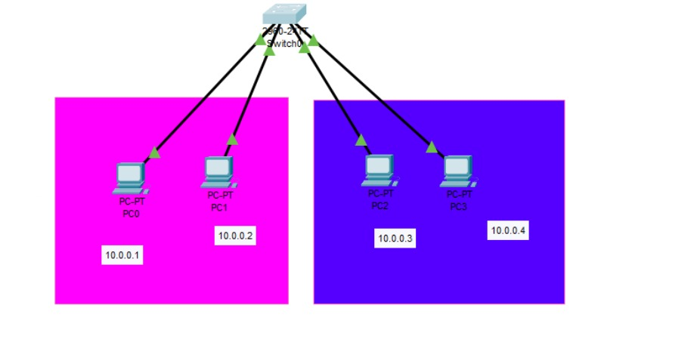

Step-5 go to switch and Double click open the cli

Step5- type Switch to privilege mode:

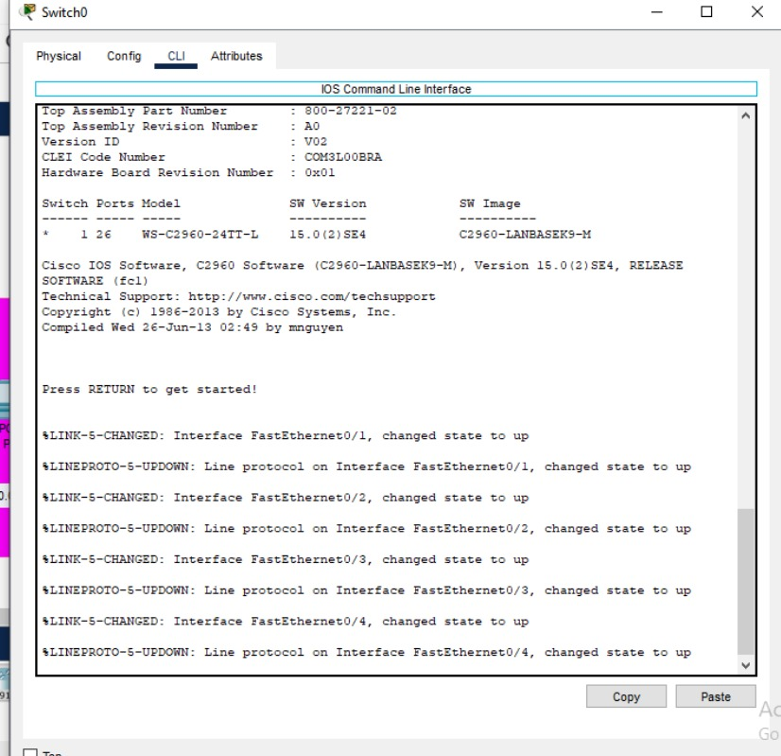

Switch>enable

Step-6

Switch to global configuration mode:

Switch#conf t

Switch(config)#

**Configuring VLAN 2:**

Switch(config)#vlan 2

Switch(config-vlan)#name office

Switch(config-vlan)#exit

**Configuring VLAN 3:**

Switch(config)#vlan 3

Switch(config-vlan)#name home

Switch(config-vlan)#exit

Configuring fastEthernet 0/1 interface:

Switch(config)#interface fastEthernet 0/1

Switch(config-if)#switchport access vlan 2

Switch(config-if)#exit

Configuring fastEthernet 0/2 interface:

Switch(config)#interface fastEthernet 0/2

Switch(config-if)#switchport access vlan 2

Switch(config-if)#exit

Configuring fastEthernet 0/3 interface:

Switch(config-if)#interface FastEthernet0/3

Switch(config-if)#switchport access vlan 3

Switch(config-if)#exit

Configuring fastEthernet 0/4 interface:

Switch(config)#interface FastEthernet0/4

Switch(config-if)#switchport access vlan 3

Switch(config-if)#

